Template for Evidence(s)
UI GreenMetric Questionnaire

University : ...
Country : ...
Web Address : …

[1] Setting and Infrastructure (SI)
SAMPLE
[1.5] Total Campus Area (meter²)

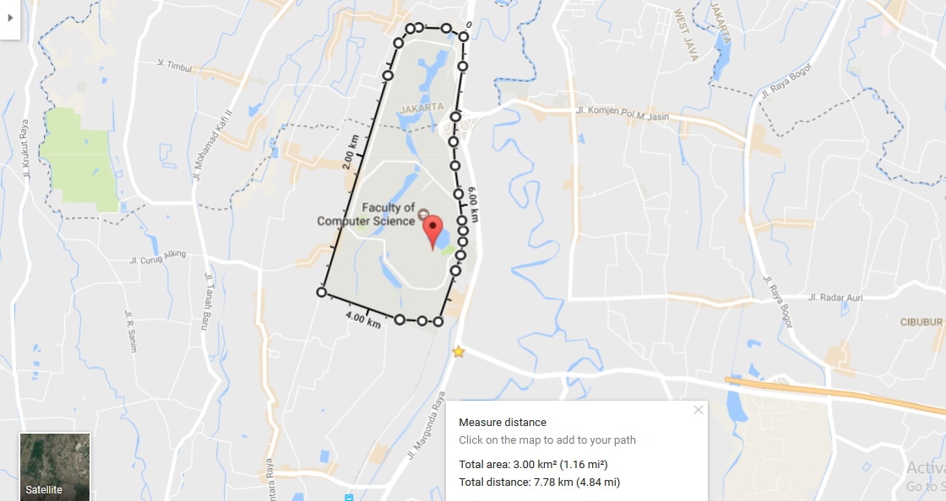
Example of Total Campus Area (Universitas Indonesia, Indonesia)

Description:
(Please describe the total area in your campus. The following is an example of the description. You can describe more related items if needed.)

The evidence provided may also include maps showing the location, area size, or distribution of facilities relevant to the indicators

Total area: 3.00 km² (1.16 mi²) = 3.000.0000 m²
Total distance/circumference: 7.78 km (4.84 mi) = 7.780 m

Additional evidence link (i.e., for videos, more images, or other files that are not included in this file):

